Autumn 1 (8 wks)  5 Sep-27 Oct | Autumn 2 (7wks)  7 Nov-22 Dec | Spring 1 (6 wks)  8 Jan-16 Feb | Spring 2 (5 wks)  27 Feb-29 Mar | Summer 1 (6 wks)  16 Apr-25 May | Summer 2 (7 wks)  4 Jun-20 Jul
Identity  Family & Friends  Relationships | Light & Dark  Day & Night  Autumn | Chinese New Year  The World  Africa  Animals | Fairy Tales  Imagination | Farm  Growing Plants  Food & Healthy Eating | Holidays  Transport  Under the Sea
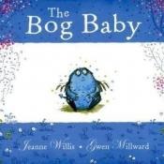  A message about what it means to really love something. When two small sisters decide to go fishing in the magic pond, they find something unexpected and much better than a frog or a newt: they find a bog baby. Small and blue with wings like a dragon, the girls love him with a passion and make a pact to make him their secret. | 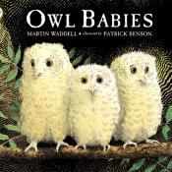  Separation is one of the big traumas of childhood. In this utterly simple yet deeply moving picture book all that happens is that three owlets are left alone whilst their mother goes off into the night to hunt for food. | 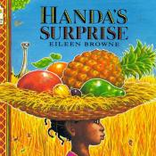  This vibrant illustrated story takes us into the world of a little girl in Kenya who plans to surprise her special friend Akeyo with a basket of fruit. | 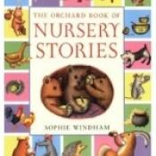  This collection of sixteen well known Nursery Stories will be enjoyed by all young children and children wiil benefit from hearing them read aloud and re read.The book has very appealing illustrations that enhance the understanding of the text. | 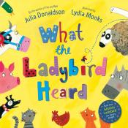  A lovely story about a ladybird who overhears a secret plan to steal the prize cow. Through team work and communication the animals work together to foil the burglars and save the cow. | 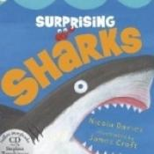  This is an excellent introduction to sharks. The book itself is full of interesting facts about sharks that will challenge the reputation of the shark as a “giant man-eating killer”. The first shark the author introduces is a Dwarf Lantern Shark that is smaller than a chocolate bar.
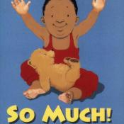  A large and loving picture book in which aunts, uncles, cousins and grandparents come to the baby’s house for a surprise birthday party for his Dad. They all love the baby SO MUCH that he falls asleep, exhausted from all the attention. | 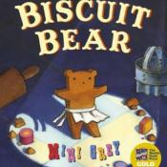  A night-time adventure as a gang of biscuit bears create a wild circus in the kitchen. | 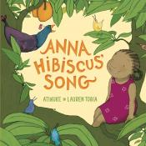  Anna Hibiscus is a small girl of dual heritage with a happy heart living with a large and loving family in Africa. She asks each member of her extended family what she should do because she feels so happy and she weaves their various responses into a song. | 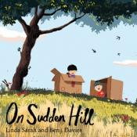  A box is a wonderful thing. Of course, it’s useful for transporting things, but its most charming uses are when it’s a robot, house or a spaceship, really anything your imagination wants. | 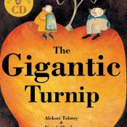  Niamh Sharkey's highly original illustrations, with their use of angles and circles, make this an exciting new interpretation of a well-known story. The text includes an interesting counting element and some use is made of shaping the typeface to accentuate the meaning of certain words. | 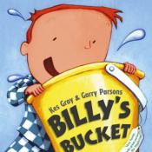  first, his parents try and persuade him to have a more conventional present but eventually they take him to Buckets “R” Us to select his gift from a huge array. Once he fills his bucket with water, Billy claims he can see all the wonders of the ocean deeps and his parents humour him.
Additional texts:

Autumn 1 (8 wks)  5 Sep-27 Oct | Autumn 2 (7wks)  7 Nov-22 Dec | Spring 1 (6 wks)  8 Jan-16 Feb | Spring 2 (5 wks)  27 Feb-29 Mar | Summer 1 (6 wks)  16 Apr-25 May | Summer 2 (7 wks)  4 Jun-20 Jul
Identity  Family & Friends  Relationships | Light & Dark  Day & Night  Autumn | Chinese New Year  The World  Africa  Animals | Fairy Tales  Imagination | Farm  Growing Plants  Food & Healthy Eating | Holidays  Transport  Under the Sea
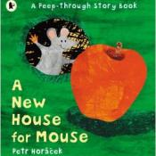 | 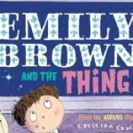 | 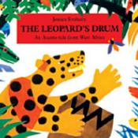 | 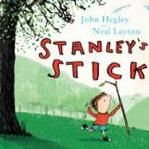 | 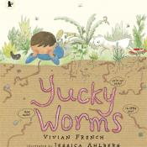 | 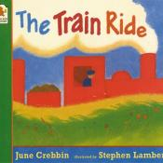
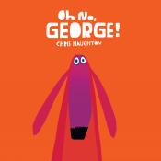 | 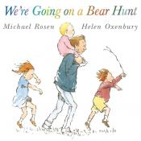 | 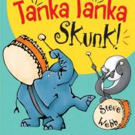 |  | 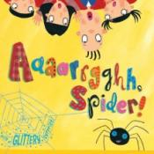 | 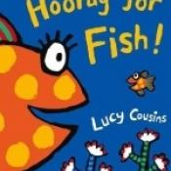
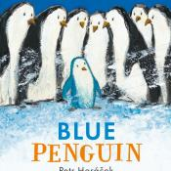 |  | 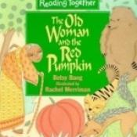 |  |  | 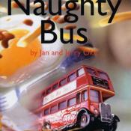
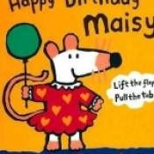 |  | 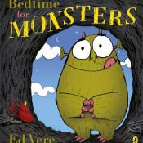
 |  | 