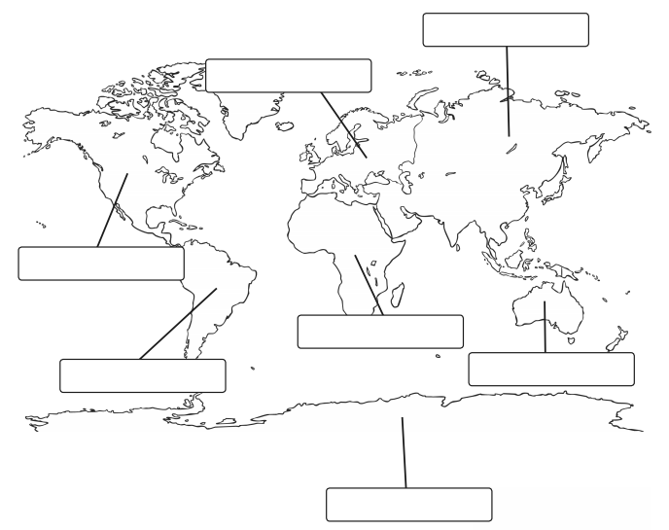

Extension

Label the following oceans:

Indian Ocean

Atlantic Ocean

Pacific Ocean

Label the following countries:

England

Italy

Brazil

Canada

Nigeria

China

New Zealand

Label the seven continents of the world.